**MICROSOFT GRAPH HISTORICAL LOAD TESTING DOCUMENT**

**Table Name: ACCESS_CARDS**

Snowflake Raw Layer Row Count: 27765

Snowflake Harmonized Layer Row Count: 27765

Column Matching?: Yes

Value Matching?: Yes

**Snowflake RAW Layer Records:**

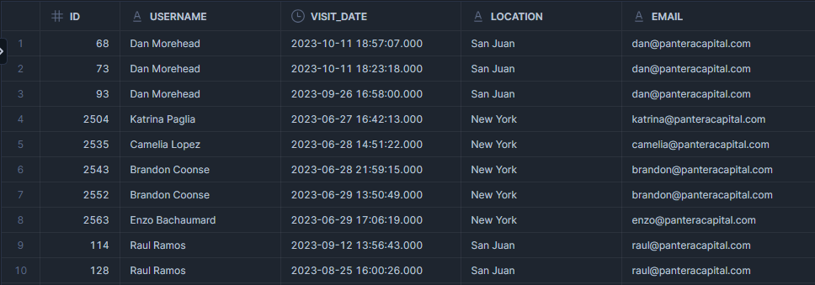

**Snowflake Harmonized Layer Records:**

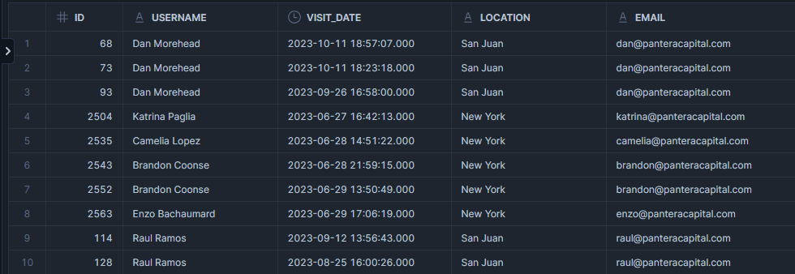

**Table Name: ACCESS_CARDS_EMAIL_MAP**

Snowflake Row Count: 120

Snowflake Harmonized Layer Row Count: 120

Column Matching?: Yes

Value Matching?: Yes

**Snowflake Records:**

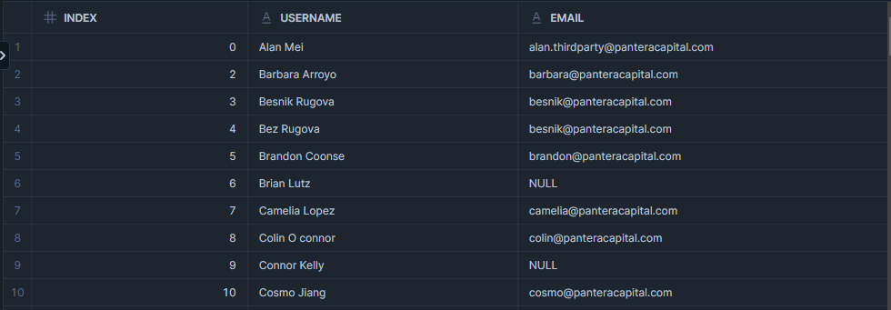

**Snowflake Harmonized Layer Records:**

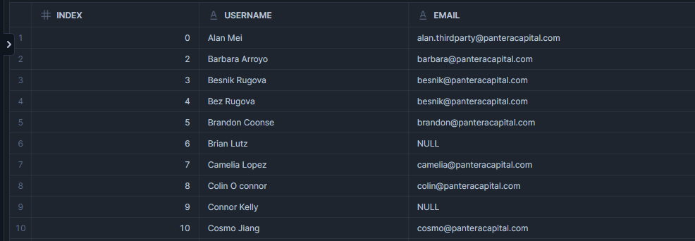

**Table Name: DEVICES**

Snowflake Row Count: 154

Snowflake Harmonized Layer Row Count: 154

Column Matching?: Yes

Value Matching?: Yes

**Snowflake Records:**

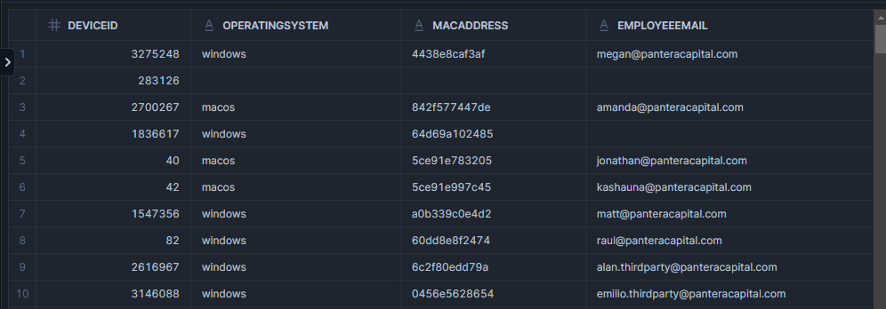

**Snowflake Harmonized Layer Records:**

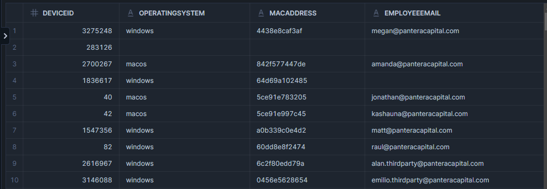

**Table Name: EMAIL_ACTIVITY**

Snowflake Row Count: 23116

Snowflake Harmonized Layer Row Count: 23116

Column Matching?: No (Extra columns has been added to the Harmonized layer table which we get from the Email_Activity API Response)

Value Matching?: Yes

**Snowflake Records:**

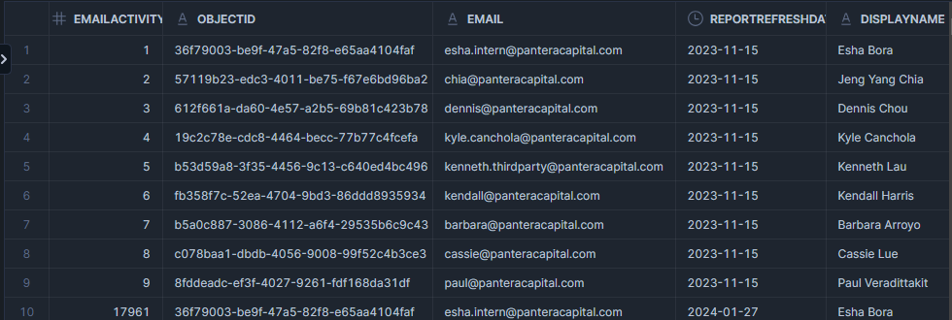

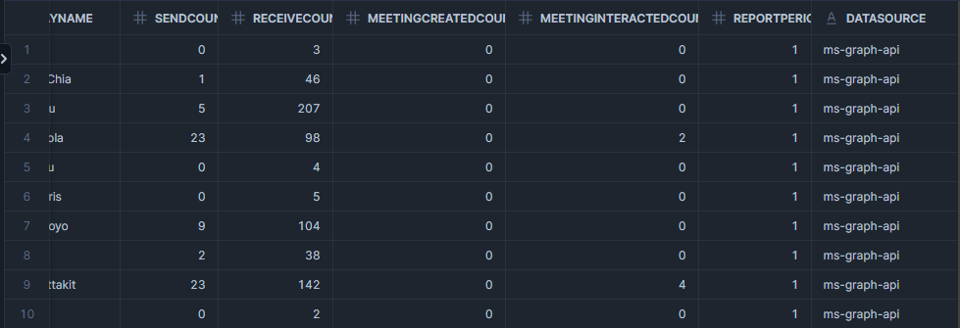

**Snowflake Harmonized Layer Records:**

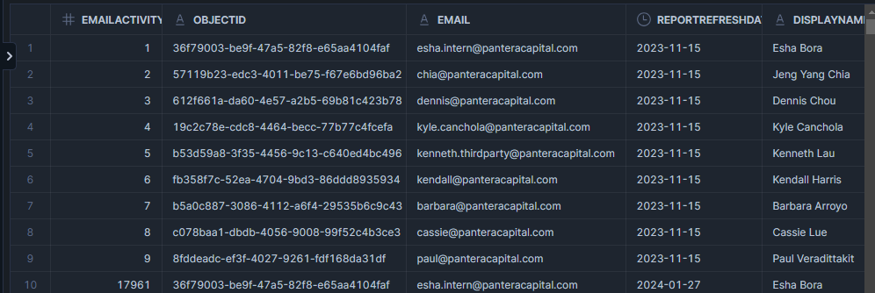

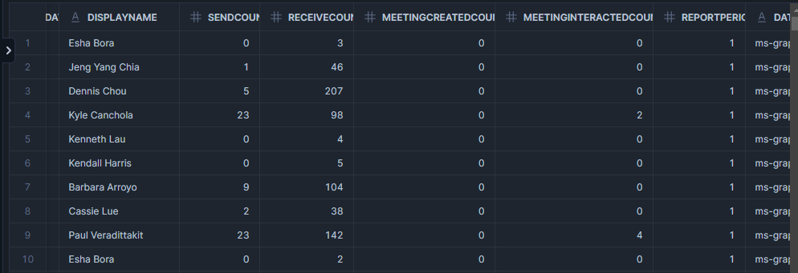

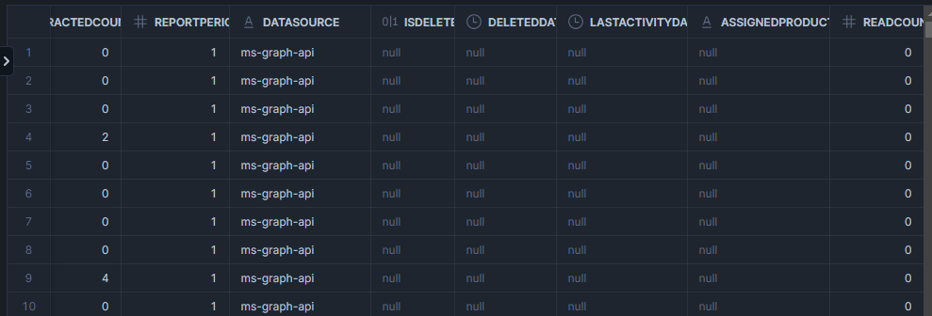

**Table Name: EMPLOYEES**

Snowflake Row Count: 125

Snowflake Harmonized Layer Row Count: 125

Column Matching?: Yes

Value Matching?: Yes

**Snowflake Records:**

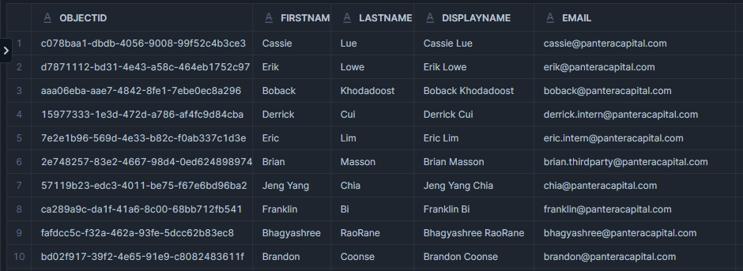

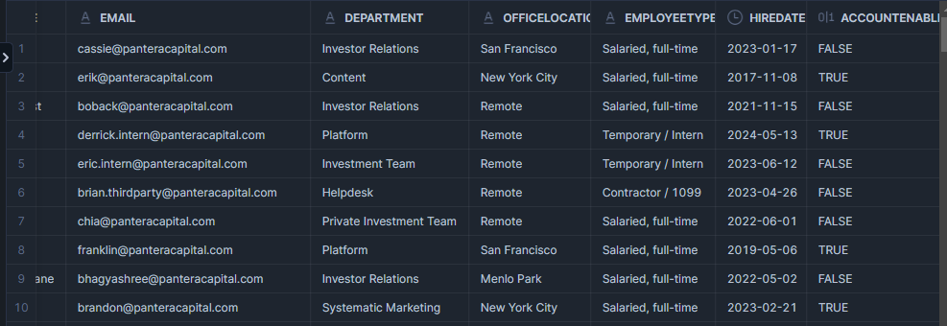

**Snowflake Harmonized Layer Records:**

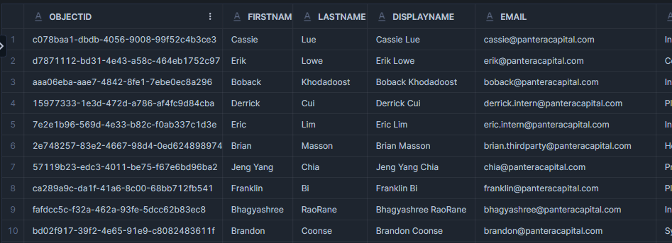

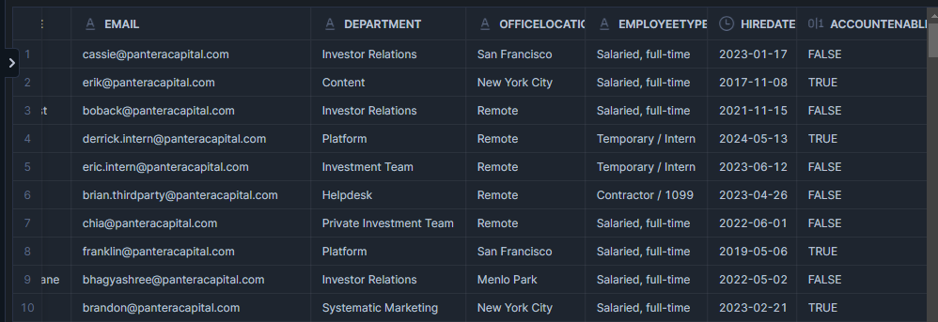

**Table Name: INTUNE_DATA**

Snowflake Row Count: 794552

Snowflake Harmonized Layer Row Count: 794552

Column Matching?: No (Extra columns has been added to the Harmonized layer table which we get from the Email_Activity API Response)

Value Matching?: Yes

**Snowflake Records:**

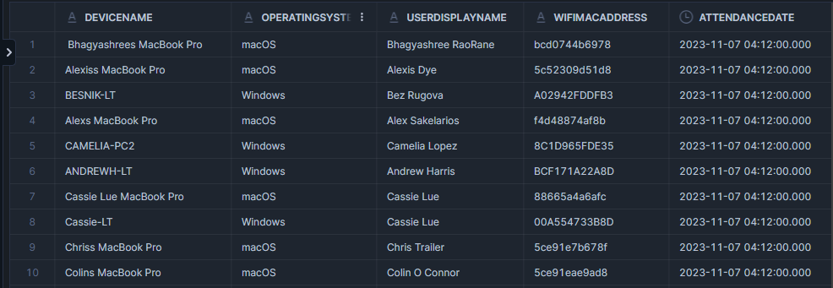

**Snowflake Harmonized Layer Records:**

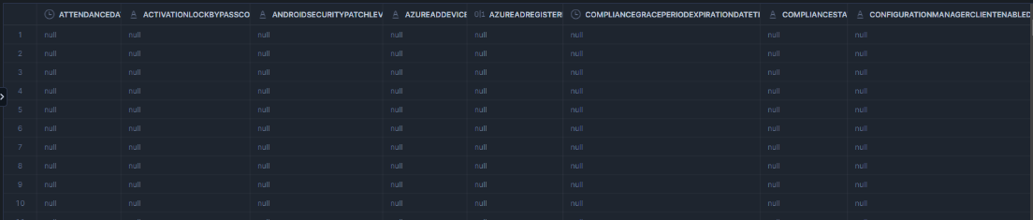

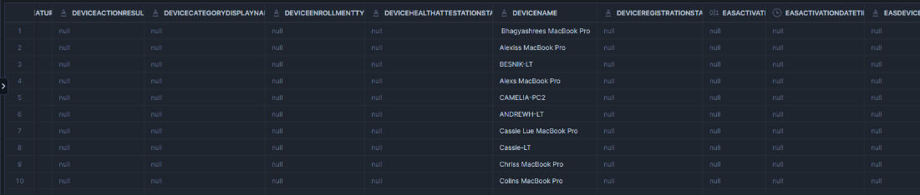

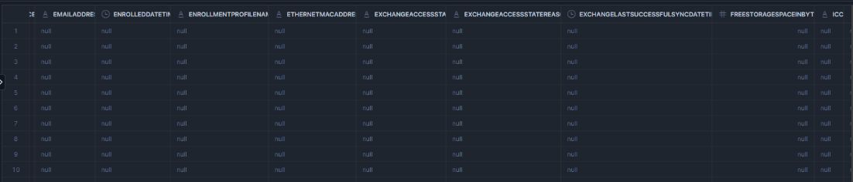

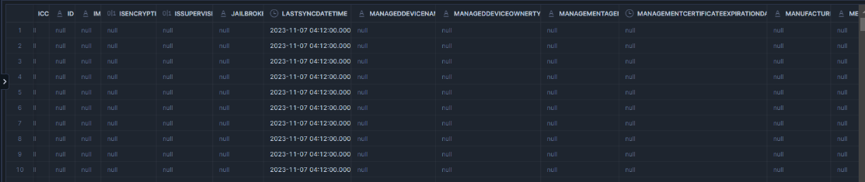

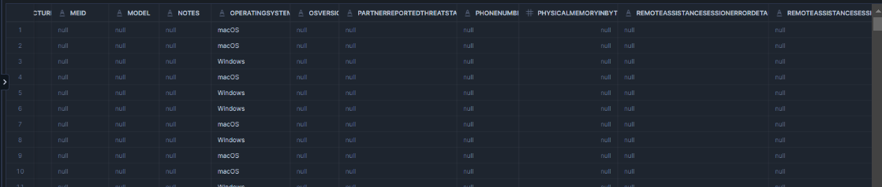

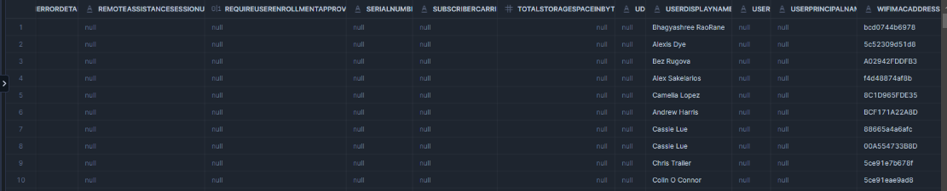

**Table Name: LOCATIONS**

Snowflake Row Count: 13

Snowflake Harmonized Layer Row Count: 13

Column Matching?: Yes

Value Matching?: Yes

**Snowflake Records:**

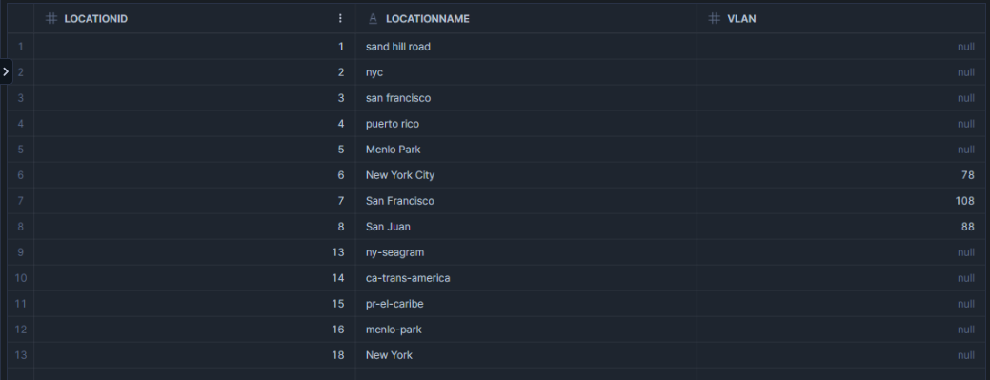

**Snowflake Harmonized Layer Records:**

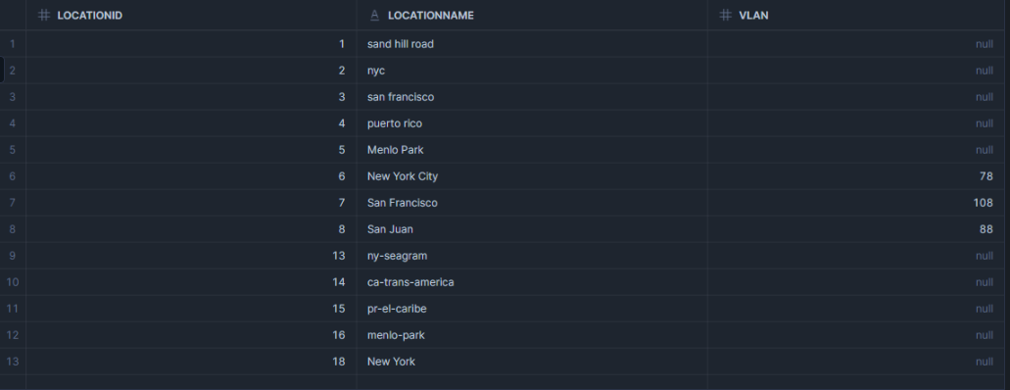

**Table Name: VISITS**

Snowflake Row Count: 330836

Snowflake Harmonized Layer Row Count: 330836

Column Matching?: Yes

Value Matching?: Yes

**Snowflake Harmonized Layer Records:**

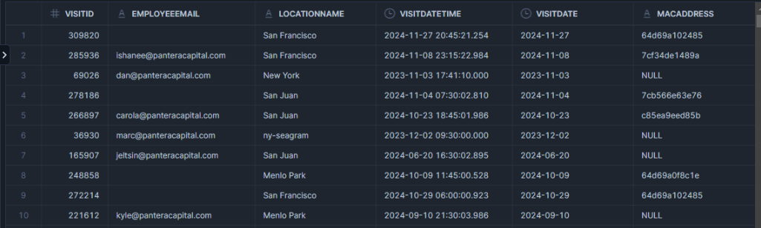

**Historical Export Records:**

